**Armor**

**Design Document for:**

# Doom Carnival

**I will find you, and I will save you Becky.**

“Stop Clownin”™

All work Copyright ©2018 by Armor

Written by Armor

Version # 1.00

Thursday, May 10, 2018Table of Contents

Name of Game 1

Design History 5

Version 1.10 6

Version 2.00 7

Version 2.10 8

Game Overview 9

Philosophy 9

Philosophical point #1 9

Philosophical point #2 9

Common Questions 9

What is the game? 9

Why create this game? 9

Where does the game take place? 9

What do I control? 9

How many characters do I control? 9

What is the main focus? 9

What’s different? 9

Feature Set 10

General Features 10

Game play 10

The Game World 11

Overview 11

World Feature 11

World Feature #1 12

World Feature #2 13

World Feature #3/final 14

The Physical World 15

Overview 15

Key Locations 15

Travel 15

Scale 15

Objects 15

Weather 15

Day and Night 15

Time 15

Rendering System 15

Overview 15

2D/3D Rendering 15

Camera 15

Overview 15

Camera Detail #1 16

Game Engine 16

Overview 16

Game Engine Detail #1 16

Water 16

Collision Detection 16

Lighting Models 16

Overview 16

The World Layout 17

Overview 17

Layout #1 17

Layout #2__________________________________________________________________________17

Layout #3__________________________________________________________________________17

Game Characters 18

Overview 18

Creating a Character 18

Enemies and Monsters 18

Rustee 19

Demons! 20

Weapons 21

Overview 21

Weapons Details #1 21

Weapons Details #2 21

Power ups 22

Slow motion 22

movement speed 22

rapid fire 22

exploding demons 22

nuke 22

movement speed 22

Rapid fire power up 23

Exploding demons power up 24

nuke 25

Musical Scores and Sound Effects 26

Overview 26

Red Book Audio 26

3D Sound 26

Sound Design 26

Single Player Game 27

Overview 27

Single Player Game Detail #1 27

Single Player Game Detail #2 27

Story 27

Hours of Game-play 27

Victory Conditions 27

Extra Miscellaneous Stuff 27

Overview 27

car 27

house 27

Mailbox 28

early demon plus light post 28

# Design History

This game is an FPS (First Person Shooter) that revolves around a man named Phillip who is out to rescue his daughter Becky from an evil clown named Rustee

## Version 1.10

1. First Version: The very first version was basically a mini game like at a carnival where you shoot plates to achieve a certain score in order to get a prize, however the goal of our game was to achieve a certain score so that you may live.

Basically, there was an evil clown that hosted the mini game. The player was to get a score of 666 to escape the game with their life. However, if the player did not achieve the score, the clown would kill them (at the beginning we didn’t decide how the player would die, but later after some thought, we gave the clown an axe).

1. There were also flaming monkey heads that you could shoot and would instantly explode. They would be similar to the bombs on fruit ninja, basically a hazard that you didn’t want to shoot. However, if the player knows that they would not achieve the score, they could shoot the monkey head to kill themselves and the clown.
2. As far as assets, we had the stand completed but we did not have the other assets 100% completed.

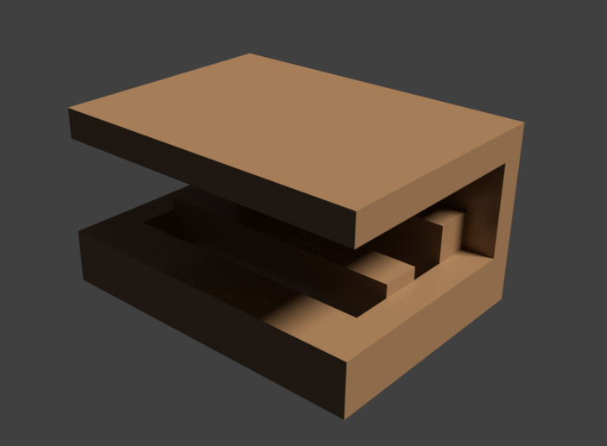

## 

## 

## Version 2.00

Version 2.00 was a completely different idea once we gained a little more knowledge in Unreal Engine.

1. This version was a FPS where the player was dropped in a world and he had to fight against an unknown number of waves of demons to survive.
2. The player spawns with a gun that is similar to the Ray Gun from Call of Duty World at War: Zombies and will use that and their wits to survive the waves.

## https://media.discordapp.net/attachments/405414441761505282/416102076414689290/p2.PNG

## Version 2.10

Version 2.10 has several small changes over that of version 2.00.

Included in the changes are:

1. Clown is now named Rustee.
2. Player is named Phillip.
3. Player is to recue his daughter Becky from Rustee.
4. Player starts outside of his house in a Cul-De-Sac.
5. Player must not only kill several demons and clowns, but also kill Rustee at the end of the game to save his daughter.

# 

# Game Overview

## Philosophy

### Philosophical point #1

As of this moment, the game is similar yet different from Call of Duty Zombies. There is still a large number of enemy AI that they player must kill in order to get to Rustee, then the player must defeat Rustee to save his daughter.

### Philosophical point #2

The goal of our company is to create this game for PC and console. We would like a wider scope of players.

## Common Questions

### What is the game?

A First Person Shooter where the player is to kill several demons and clowns and their boss in order to save his daughter.

### Why create this game?

Because we have to.

### Where does the game take place?

The game takes place in town called Asa-Madera in a Cul-De-Sac. The player spawns outside of a house within the CDS.

### What do I control?

The player controls a character named Phillip. It will be in a first-person perspective.

### How many characters do I control?

The player only controls one character.

### What is the main focus?

The main focus for this game is for Phillip to rescue his kidnapped daughter from the captivity of Rustee the Clown.

### What’s different?

Currently most of the games now are MMO or RPG open-world type games. This game is slightly old school in that it is a single player game against a vast amount of AI and one main boss to reach a certain goal.

# Feature Set

## General Features

Mid-Size world

Demons

Clowns

3D graphics

## Gameplay

Kill tons of evil clowns and demons!

Exact revenge on an Evil clown boss!

Find Easter Eggs!

# The Game World

## Overview

Map is a Cul-De-Sac that ends in a T and across the street is a carnival.

## World Feature EDITED: 03/03/2018

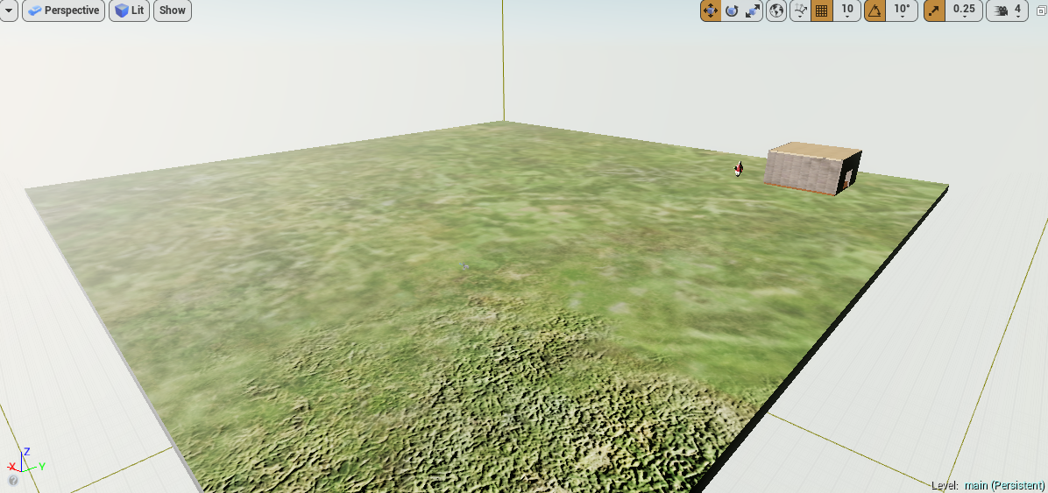

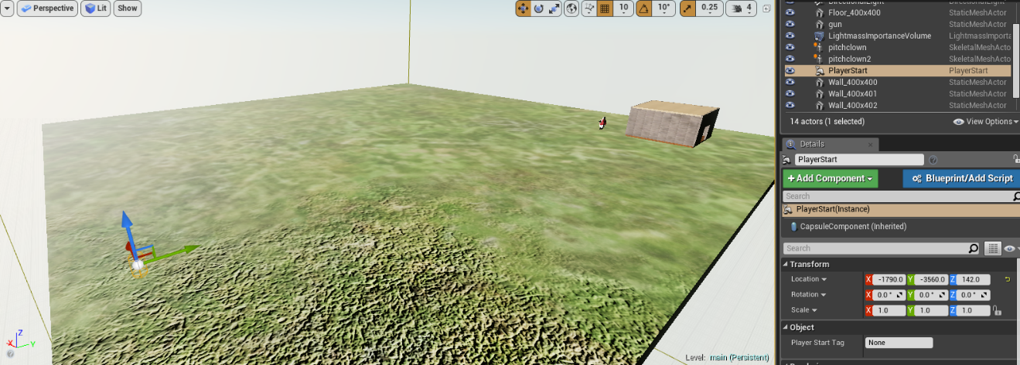

This is the absolute barebones of our first map idea. Since then, we’ve made some changes.

At this point in time, we had only decided that it was going to be an endless wave FPS with no real goal other than to survive for as long as possible.

World Feature #1 EDITED: 03/05/2018

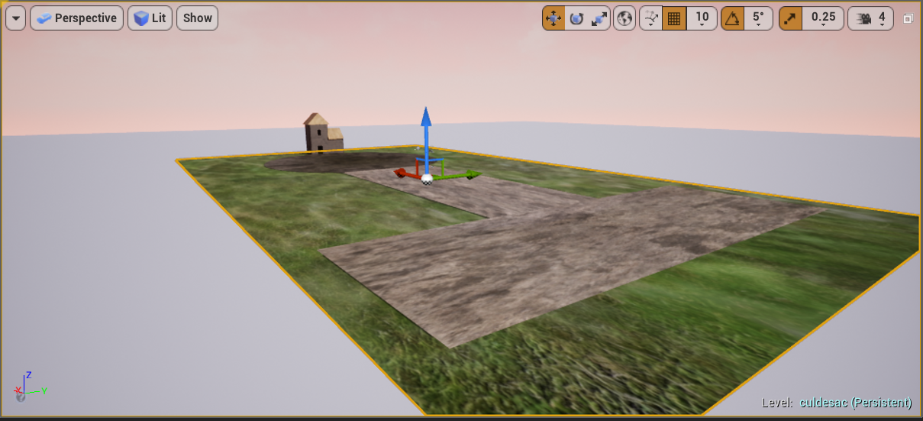

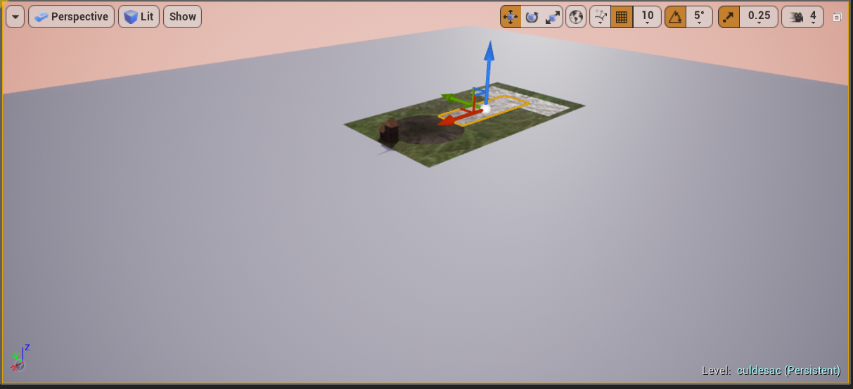

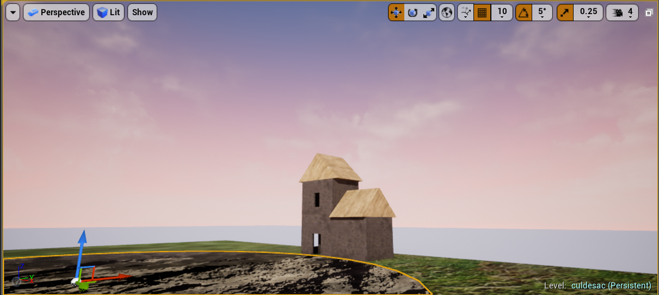

## World Feature #2 EDITED: 03/07/2018

Hidden areas, carnival, evil clown population.

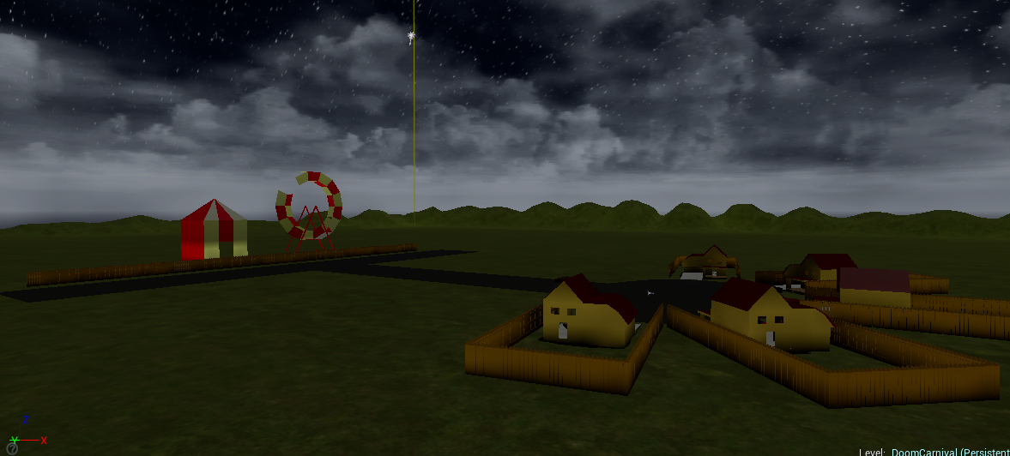

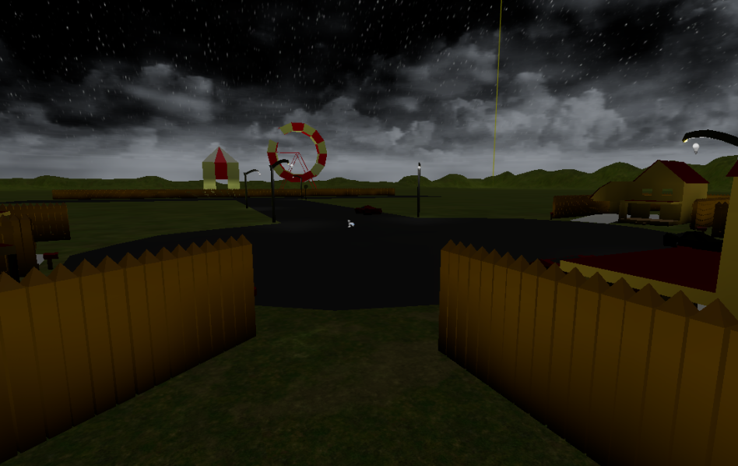

## World Feature #3/final EDITED: 05/10/2018

Functioning power ups, clowns spawn, and the ray gun and ability to play have finally been introduced.

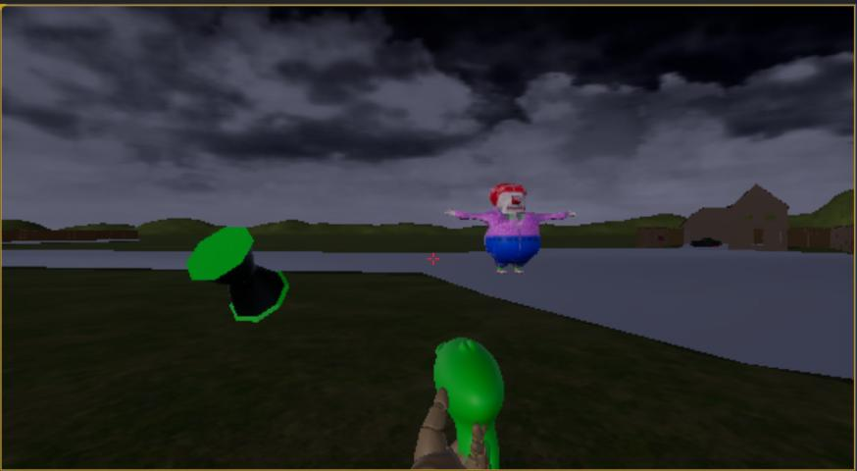

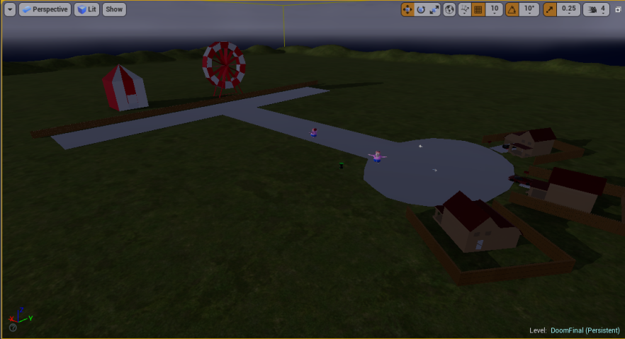

## The Physical World

### Overview

Waves of clowns and demons come and need to be killed in order to save your daughter

### Key Locations

The key location is the street where all of the action will be taking place.

### Travel

Character is in 1st person. WASD is to control, mouse is to aim, and left click is to shoot.

### Scale

The scale of the level is not that large. In game, everything appears normal sized.

### Objects

Homes, cars, a carnival.

### Weather

Clear night weather.

### Day and Night

The game just takes place at night.

### Time

The game will remain at night time, the whole time.

## Rendering System

### Overview

We are using Unreal Engine 4 to render the graphics.

### 2D/3D Rendering

Unreal Engine 4

## Camera

### Overview

First person view

### Camera Detail #1

As you control your character, the camera moves as well.

## Game Engine

### 

### Overview

Many triple AAA games use Unreal Engine 4, with proper knowledge, anything is possible.

### Game Engine Detail #1

The game engine will keep track of health.

### Hill Range

There will be a hill range that maintains the border of the level so that the player cannot fall off the edge.

### Collision Detection

Our game will have simple collision detection.

## Lighting Models*

### Overview

The lighting will be a directional lighting source that will basically represent the moon.

# The World Layout

## Overview

The game takes place in a cul-de-sac located on a street where a carnival has popped up out of nowhere.

**Layout # 1 EDITED: 03/03/2018**

In this layout, the map was fairly simple. At this point, there was only a light source, a small building, a player-start (noted in the second photo in Game Layout) and a clown which would be replicated endlessly. It was a rough draft for the clown, so it doesn’t have any facial features.

**Layout # 2 EDITED: 03/05/2018**

In this layout, the map started to look more like the street level 1 is based on. Here we have a 2 story house that will be used as the starting point for Phillip, an actual cul-de-sac, the intersecting streets, and the total scale of the level can be seen. At this point we are close to our final level design.

**Layout # 3 EDITED: 03/07/2018**

In this layout, we have adjusted the setting to night. We have finished adding the final necessary assets to our level which include, a stop sign, light posts, cars, our final houses, the carnival, a Ferris wheel, mail boxes, and the hill terrain in the background. At this stage we have finished our final design and are ready to implement code to make it run.

# Game Characters

## Overview

Character is a human, a father named Phillip.

## Creating a Character

Our character isn’t personalized since this is a first person shooter. The camera will never show the actual character model of the player.

## Enemies and Monsters

The enemies would be clowns and demons. They will spawn in hordes. Rustee the Clown will be the boss.

Rustee

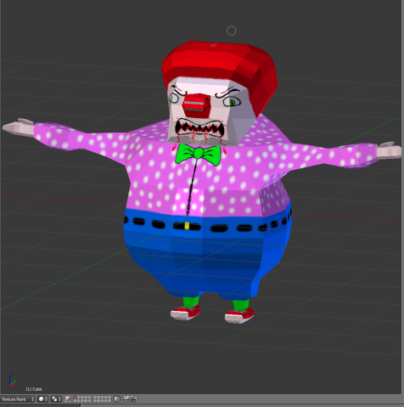

Demons! 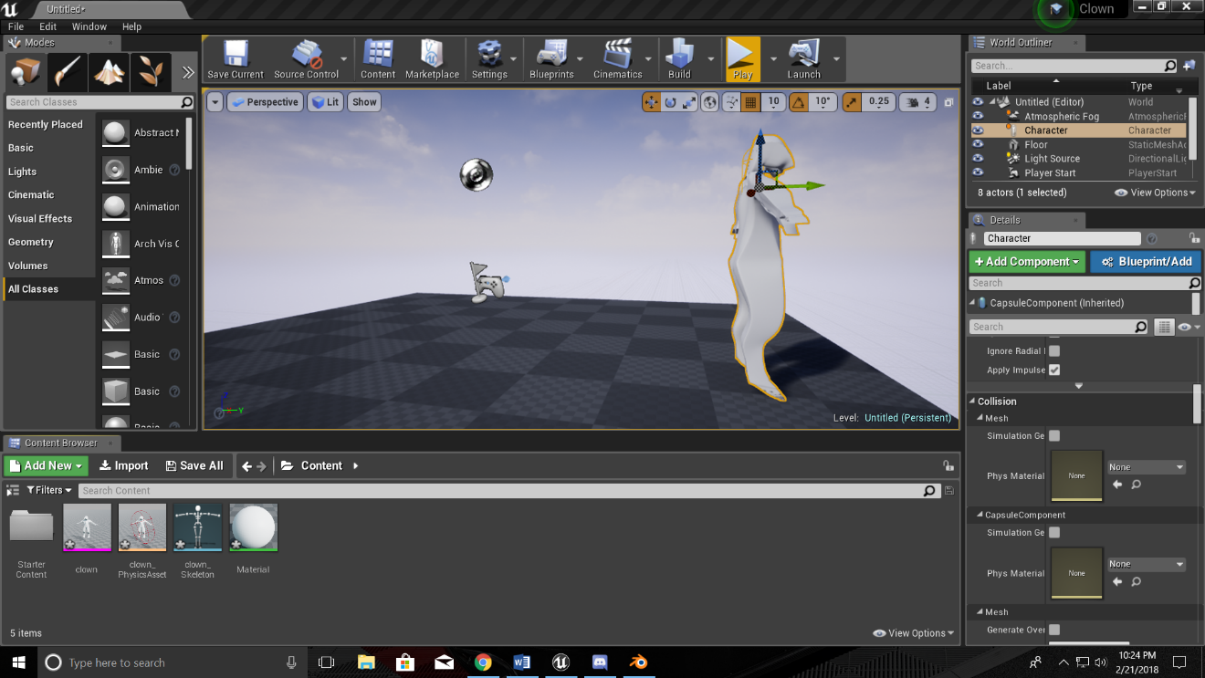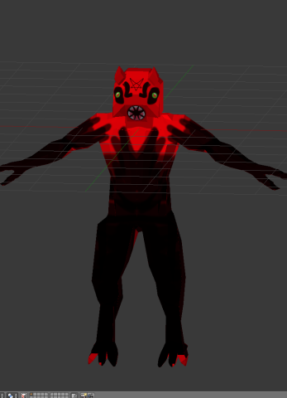

# Weapons

## Overview

The only weapon for use is a ray gun.

## Weapons Details #1

The ray gun was made from a separate program called blender.

## Weapons Details #2

The ray gun will shoot projectiles that resemble short beams of light.



# Power ups Edited 5/10/18

## Overview

There will be power ups scattered around the level that can be picked up and may affect your weapon, character, or the enemies.

## Slow Motion

All time is slowed for 6 seconds.

IN PROGRESS

## Movement speed

Doubles the character’s movement speed for 10 seconds.

## Rapid fire

Increases the ray gun’s rate of fire for 15 seconds.

## Health increase

The player’s HP is doubled for 15 seconds.

## Exploding demons

Killing demons causes them to explode and damage nearby enemies.

## Nuke

Wipes out all demons CURRENTLY on the map.

Movement speed.



.

Rapid fire power up. 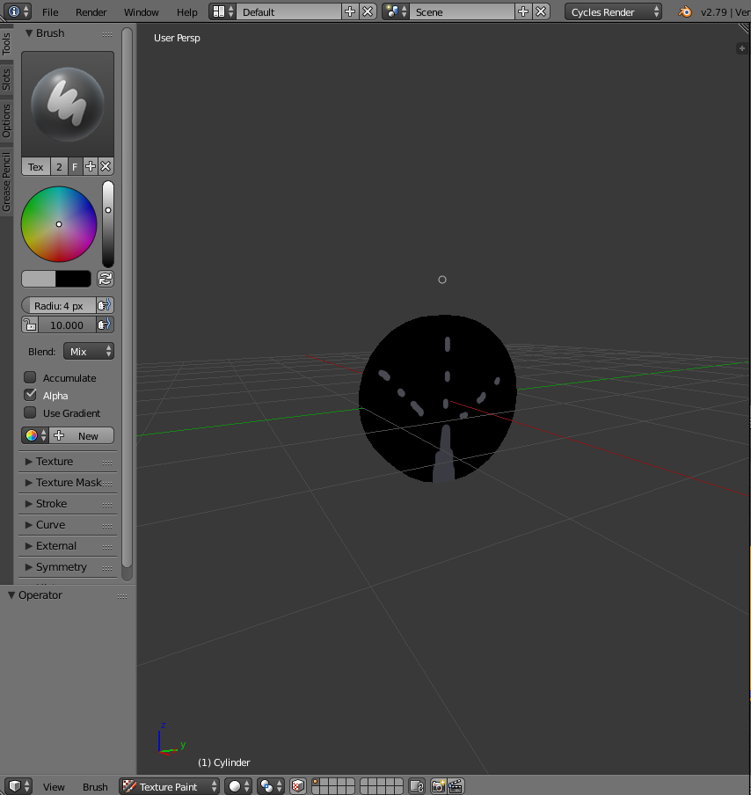

Exploding demons power up. 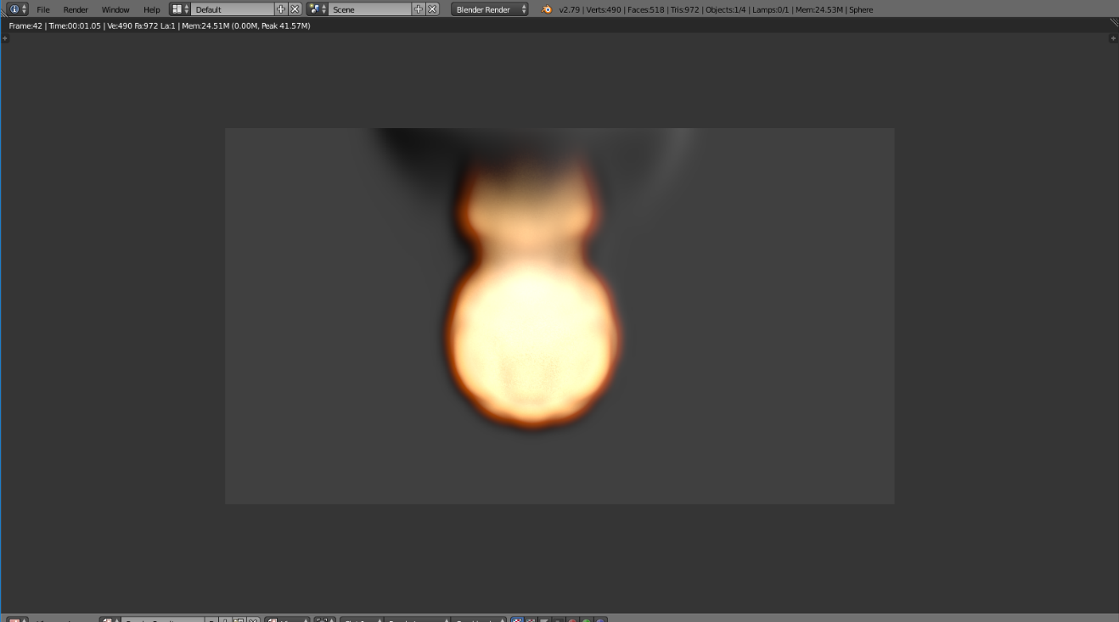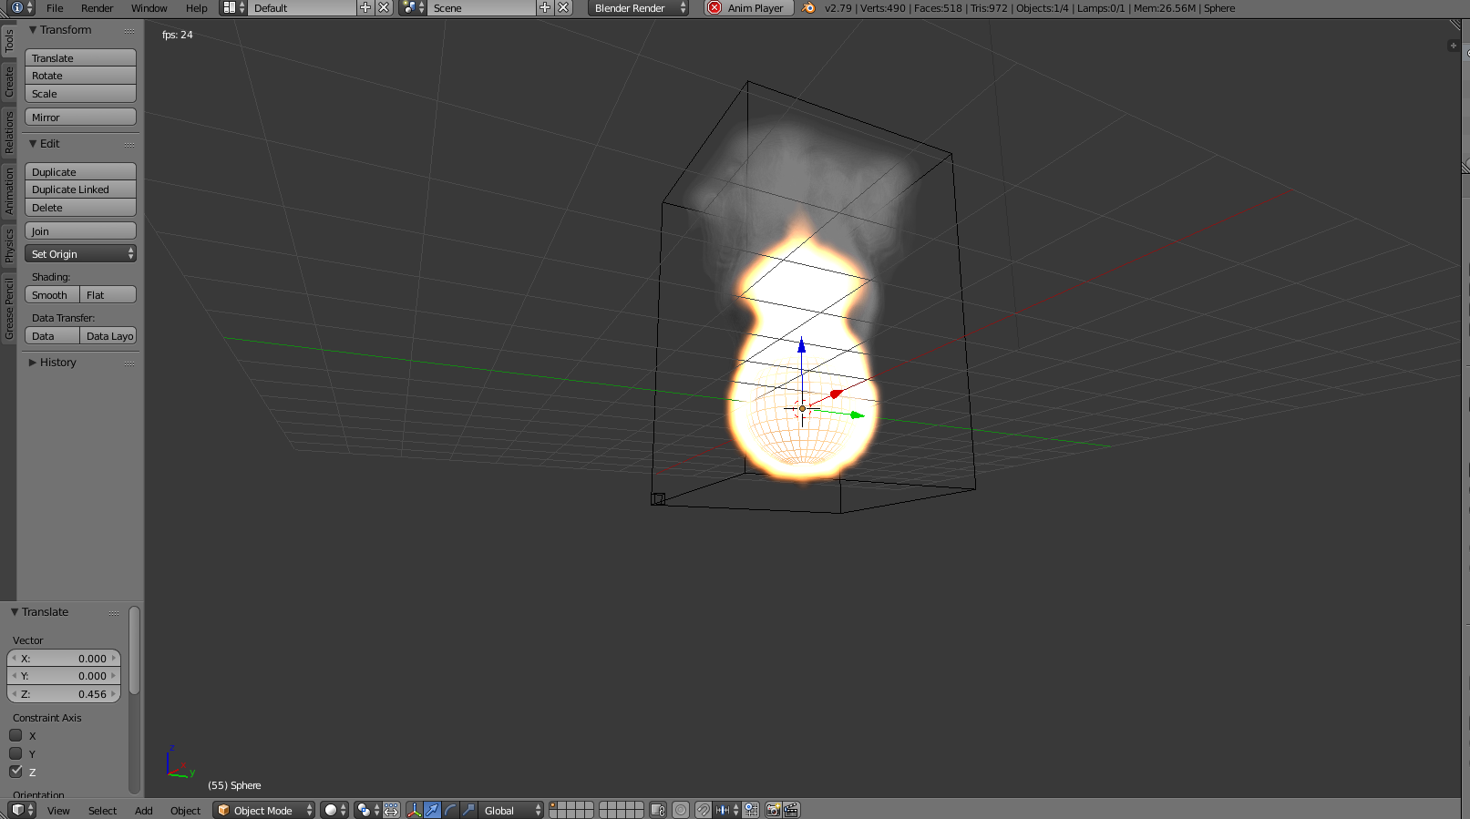

Nuke. 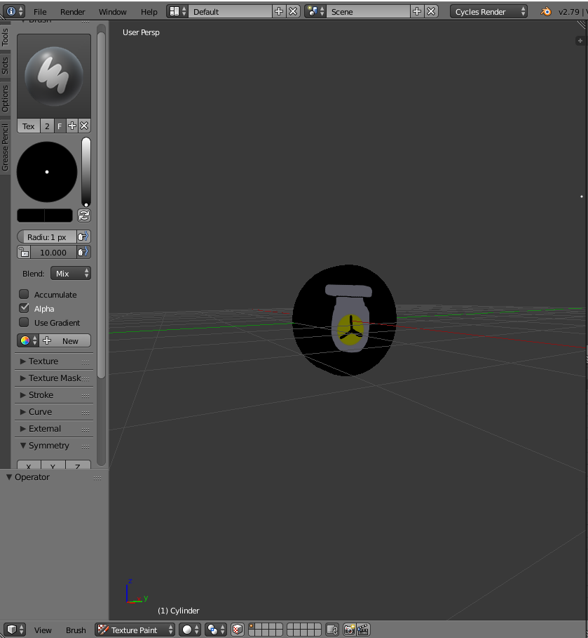

# Musical Scores and Sound Effects*

## Overview

The AI (clowns and demons) will have a groaning or laughing sound depending on the AI. Rustee’s voice is still in the works.

# Single-Player Game

## Overview

Phillip (the player) spawns outside of his house to find out that his daughter has been taken by demons and clowns from the carnival that popped up down the street. It is up to Phillip to eliminate all of them to rescue his daughter.

**Extra Miscellaneous Stuff**

## Overview

The vehicles and homes.

Car

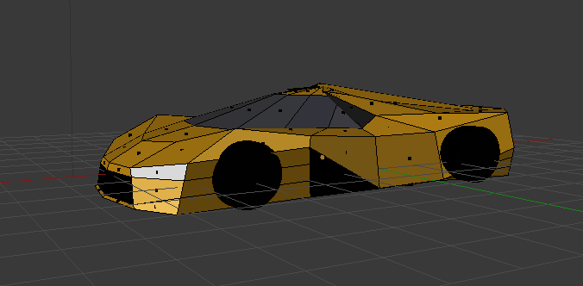 House

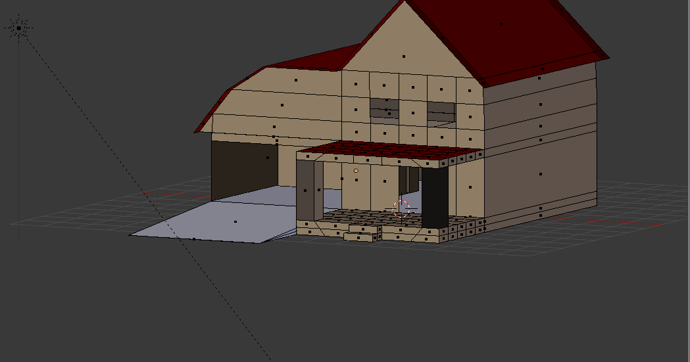

Mailbox

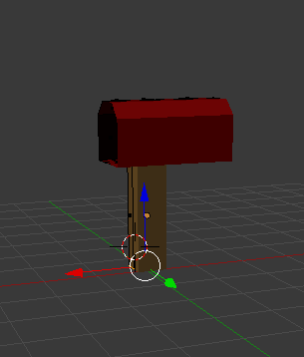

Early demon plus light post.

